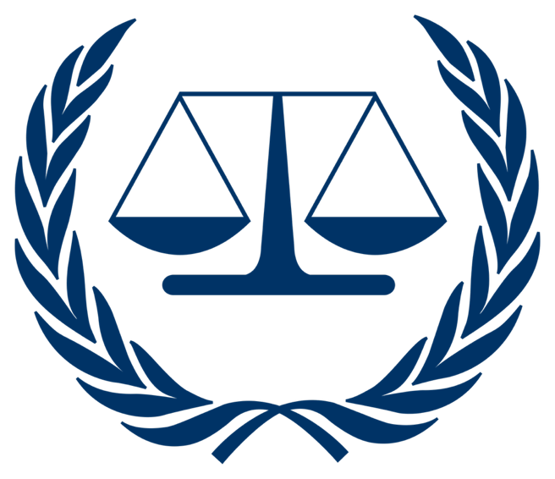

Topic 1

Prosecution Vs Richard Cheney

-President’s Letter-
-Overview-
-Timeline-
-Charges-
-Definitions-
-President’s Letter-

Justitia est caeca, justice is blind; it does not care about ethnicity, wealth, status, race or religion; it cares about the facts and the arguments presented, and it enforces the law. Dear Advocates and Jury of the International Criminal Court, you all have been chosen to be part of a high-pressure and intense committee, one with fierce competition, but it still stands as one of the best committees in Model UN conferences. Welcome to the ICC.

Advocates and Jury, no matter the position you are allocated you will still have an extremely important role, one that you will have to fulfil to the best of your ability, Advocates will have to present their best cases and arguments, ones that are compelling enough to get the jury on their side, meanwhile the Jury will be listening to both sides and they will maintain a fair and unbiased approach to make sure that the law is upheld in the court and that the verdicts are fair. I have been to or seen almost every committee that Model UN conferences have, and trust me when I say this, court remains my favourite one, and once you get to experience it, you will realise how the professional and strict procedure of court can be very fun and heated.

So to the Advocates, research, get the strongest witnesses to support your side, use legal concepts and terms to further strengthen your arguments and then present them to the best of your ability in court, to the Jury approach these cases with an open mind, no matter how intense and disturbing the charges may seem, because as I already said, justice only cares about the arguments and evidence presented, and that legal concept will be upheld in our court to ensure that both verdicts are fair and that justice is served properly.

-Overview-

Richard Cheney was the 46th Vice President of the United States to then- President George Bush, Cheney served from 2001 to 2009, during his time as Vice President he oversaw many major US related events such as the September 2001 attack by al-Qaeda against the United States (Commonly referred to as 9/11), and during his time as Secretary of Defense he oversaw Operation Desert Storm in the Gulf War, he was a very influential figure due to his prior extensive experience in government and defense and he held a couple of roles in the government such as Chief of Staff and being the US representative for the state of Wyoming before becoming the Vice president.

Cheney played a pivotal role in shaping US foreign policy following 9/11, and he was a leading advocate for the 2003 invasion of Iraq on the basis that Saddam Hussein and al-Qaeda had ties, and that Iraq possessed Weapons of Mass Destruction (WMDs). The invasion of Iraq led to hundreds of thousands of Iraqi deaths, major regional destabilisation and the abuse of detainees, and due to the fact that he claimed that there were no doubts about Iraq having WMDs and terror links, this further influenced the October 2002 authorisation for use of military force against Iraq resolution.

His advocacy for the invasion of Iraq was based on evidence and intelligence that was later proved to be false, which included the claim of Iraq's possession of WMDs and Saddam Hussein having ties to al-Qaeda. These efforts of pushing this false intelligence are what shaped then Secretary of State Colin Powell’s speech on February 5, 2003, where he stood in the UNSC and portrayed those shaky claims as foolproof evidence, and then this led to the invasion of Iraq in March 2003, the resulting occupation saw major human rights violations in the infamous Abu Ghraib prison and the death of hundreds of thousands of Iraqis.

-Timeline-

September 11 to 12 / 2001: Amid the chaos of 9/11, Cheney pushes the Bush team to target Iraq, citing ties between Saddam Hussein and al-Qaeda.

January / 2002: Bush’s State of the Union names Iraq the “Axis of Evil”

March / 2002: Cheney meets CIA analysts, and he pressures for Iraq WMD evidence.

August / 2002: Cheney, meeting the press, claims that there is “overwhelming evidence” of Saddam Hussein's nuclear reconstitution.

September / 2002: Cheney cites the Atta-Prague meeting linking al-Qaeda, and the Downing Street memo reveals fixed U.S./UK intelligence around the invasion policy.

October / 2002: The U.S. Congress passes the AUMF (Authorisation for Use of Military Force) against Iraq.

February / 5 / 2003: Colin Powell gives a speech in the UNSC (United Nations Security Council), and he uses the Cheney-backed WMDs evidence.

March / 20 / 2003: The U.S. invasion of Iraq begins without UN approval.

April / 2004: Abu Ghraib prison torture photos emerge that were tied to Cheney’s interrogation policies.

-Charges-

Article 7 – Crimes against humanity
Crimes against humanity mean any of the following acts when committed as part of a widespread or systematic attack directed against any civilian population, with knowledge of the attack:
- Murder
- Extermination
- Enslavement
- Deportation or forcible transfer of population (e) Imprisonment or other severe deprivation of physical liberty in violation of fundamental rules of international law
- Torture
- Rape, sexual slavery, enforced prostitution, forced pregnancy, enforced sterilisation, or any other form of sexual violence of comparable gravity
- Persecution against any identifiable group or collectivity on political, racial, national, ethnic, cultural, religious, gender, as defined in paragraph 3, or other grounds that are universally recognised as impermissible under international law, in connection with any act referred to in this paragraph or any crime within the jurisdiction of the Court
- Enforced disappearance of persons
- The crime of apartheid
- Other inhumane acts of a similar character intentionally causing great suffering, or serious injury to body or to mental or physical health.

Article 8 bis – Crimes of Aggression
Aggression: Aggression refers to the use of armed force by a State against the sovereignty, territorial integrity, or political independence of another State, or in any other manner inconsistent with the Charter of the United Nations. The crime of aggression involves leaders, planners, or decision-makers in initiating and executing an act of aggression that, by its character, gravity, and scale, constitutes a manifest violation of the Charter of the United Nations. Acts Considered as Acts of Aggression Include:
- Invasion or attack by the armed forces of a State on the territory of another State.
- Military occupation, however temporary, resulting from such invasion or attack, or any annexation by the use of force of the territory of another State or part thereof.
- Bombardment by the armed forces of a State against the territory of another State.
- The blockade of the ports or coasts of a State by the armed forces of another State.
- An attack by the armed forces of a State on the land, sea, or air forces, or marine and air fleets of another State.
- The use of armed forces of one State which are within the territory of another State, with the agreement of the receiving State, in contravention of the conditions provided for in the agreement or any extension of their presence in such territory beyond the termination of the agreement.
- Allowing a state's territory, which it has placed at the disposal of another State, to be used by that other State for perpetrating an act of aggression against a third State.
- Sending by or on behalf of a State of armed bands, groups, irregulars, or mercenaries, which carry out acts of armed force against another State of such gravity as to amount to the acts listed above, or its substantial involvement within.

Article 8 – War Crimes
War Crimes: War crimes are serious violations of the laws and customs of war. They are committed during armed conflicts, either international or non-international. Examples include: ·
Wilful killing.
- Torture or inhumane treatment.
- Unlawful deportation or confinement.
- Taking hostages.
- Attacking civilians or civilian objects.
- Using prohibited weapons.
- Recruiting and using child soldiers.
- Attacking humanitarian workers or peacekeepers.

-Definitions-

WMDs (Weapons of Mass Destruction): WMDs are devices that are created to cause mass destruction and death; the device could be biological, nuclear, chemical etc, The point of the device is to cause severe injury, harm the environment, and cause destruction.

The U.S. Congress: Congress is the law-making section of the U.S. government (Legislative). It is divided into 2 parts: the Senate and the House of Representatives. A bill needs approval from both houses to become a law.

Atta-Prague Meeting: This is a meeting that refers to unconfirmed reports made after 9/11, which suggest that one of the hijackers of the planes, a man named Mohammad Atta, met with an Iraqi intelligence officer in Prague, which suggests Iraqi involvement in the attacks on 9/11, but there was never any concrete evidence of this meeting.

Al-Qaeda: This is a terrorist organisation created by Osama Bin Laden and others with the sole purpose of opposing foreign (Particularly Western and U.S.) influence in muslim countries.

Gulf War: This was a war waged by the U.S. and 35 allies against Iraq as a response to its attack on Kuwait.

(Other definitions will be made clear through your research and through the training sessions held by your chairing panel)

