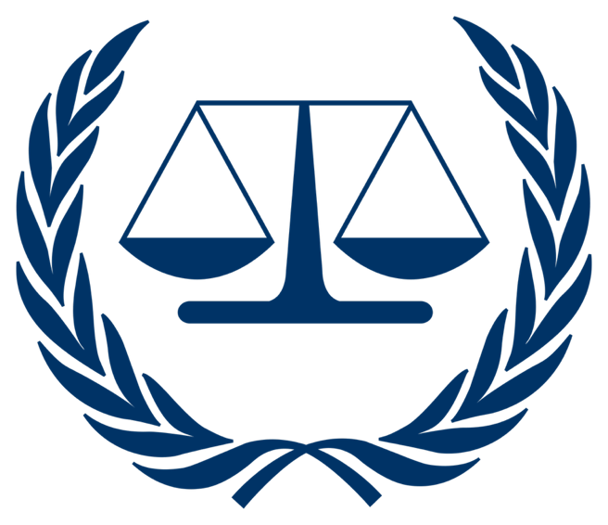

Topic 2

Prosecution Vs Radovan Karadzic

-Overview-
-Timeline-
-Charges-
-Definitions-

-Overview-

Radovan Karadzic served as the President of Republika Srpska from 1992 to 1996, in the political leadership that directed the ethnic cleansing campaigns against Bosniak and Croat civilians. Karadzic was a psychiatrist by training, and he co-founded the Serbian Democratic Party. He became a key figure in the Bosnian Serb strategy during the Dissolution of Yugoslavia. He oversaw atrocities that included mass executions, concentration camps, and forced displacements, all as part of a policy to create a pure Serb territory.

Karadzic held a pivotal role in the 44-month siege of Sarajevo, under Ratko Mladic’s command. Serb forces bombarded civilian areas, killing many civilians, including children. Karadzic authorized ethnic cleansing operations across eastern Bosnia, most notably in the July 1995 Srebrenica genocide, where over 8000 Bosniak men and boys were executed systematically. This created a criminal enterprise with Mladic and Slobodan Milosevic to remove non-Serb populations through means such as murder, rape, and terror.

These campaigns resulted in countless deaths and displaced citizens. Measures such as ethnic cleansing, terror, rape, and murder were used to ensure that the objective of controlling the ethnicities in the area would be completed. Karadzic also used rhetorical language to dehumanize Bosniaks, and he celebrated the completion of military plans and acts as victories. All of this, coupled with his control of the VRS, led to countless atrocities.

-Timeline-

April / 1992: Karadzic demands the creation of strictly Serb areas through the use of ethnic cleansing, and Bosnia declares independence.

May / 1992: The Siege of Sarajevo begins, and Karadzic forces the systematic killing of civilians.

June / 1992: Concentration camps are authorized by Karadzic. Bosniaks and Croats face torture, rape, and mass killings as a result.

July / 1992: Karadzic threatens Bosniaks with extermination, and the ethnic cleansing intensifies.

1993: Karadzic was able to maintain terror campaigns by attacking UN-designated safe areas made for Bosniaks; he was able to do that by continuously rejecting ceasefires.

July / 1995: The Srebrenica genocide takes place, over 8000 men and boys were executed following a (VRS) separation order issued by Karadzic, and he oversees the final wave of forced expulsions, which marked the completion of the ethnic cleansing objective.

-Charges-

Article 6 – Genocide
Genocide: Genocide is defined as any of the following acts committed with the intent to destroy, in whole or in part, a national, ethnic, racial, or religious group:
- Killing members of the group.
- Causing serious bodily or mental harm to members of the group.
- Deliberately inflicting on the group conditions of life calculated to bring about its physical destruction in whole or in part.
- Imposing measures intended to prevent births within the group.
- Forcibly transferring children of the group to another group.

Article 7 – Crimes against humanity
Crimes against humanity mean any of the following acts when committed as part of a widespread or systematic attack directed against any civilian population, with knowledge of the attack:
i. Murder
ii. Extermination
iii. Enslavement
iv. Deportation or forcible transfer of population (e) Imprisonment or other severe deprivation of physical liberty in violation of fundamental rules of international law
v. Torture
vi. Rape, sexual slavery, enforced prostitution, forced pregnancy, enforced sterilisation, or any other form of sexual violence of comparable gravity
vii. Persecution against any identifiable group or collectivity on political, racial, national, ethnic, cultural, religious, gender, as defined in paragraph 3, or other grounds that are universally recognised as impermissible under international law, in connection with any act referred to in this paragraph or any crime within the jurisdiction of the Court
viii. Enforced disappearance of persons
ix. The crime of apartheid
x. Other inhumane acts of a similar character intentionally causing great suffering, or serious injury to body or to mental or physical health.

Article 8 – War Crimes
War Crimes: War crimes are serious violations of the laws and customs of war. They are committed during armed conflicts, either international or non-international. Examples include: ·
Wilful killing.
- Torture or inhumane treatment.
- Unlawful deportation or confinement.
- Taking hostages.
- Attacking civilians or civilian objects.
- Using prohibited weapons.
- Recruiting and using child soldiers.
- Attacking humanitarian workers or peacekeepers.

-Definitions-

VRS (Vojska Republike Srpske): A Bosnian Serb army under the political control of Karadzic.

Joint Criminal Enterprise (JCE): This is a legal doctrine that’s very important in international law, and it holds individuals responsible for crimes committed in a group with shared criminal intent and purpose, even if they did not physically commit the crime.

Srebrenica: A UN safe zone for Bosniaks where over 8000 men and boys were executed following its occupation by Serb forces.

Sarajevo Siege: This was a 4-year blockade where Serb forces encircled the city, killing over 5000 non-Serb civilians.

Republika Srpska: A Bosnian Serb territory created by Karadzic in 1992 through ethnic cleansing to separate from Bosnia

(Other definitions will be made clear through your research and through the training sessions held by your chairing panel)

